Expermiment 5

# AIM: Using php and mysql develop a fully functional login and registration form. Add features such as forgot password and password matching

**Theory:** we used html and php to access the database. During registration the values of email , username and password were saved in the database which were later checked during login . if the username or email or password isn’t entered the user is given a error message saying the required field is empty. if correct username and password is entered the user was logged in otherwise was shown an error. A forgot password button was given on login page which allowed the user to view password in case he forgot his password. the us was asked for his username and email if the entered username and email were correct the password was shown to user else was given an error saying enter valid email and username

**Output:**

the login page:

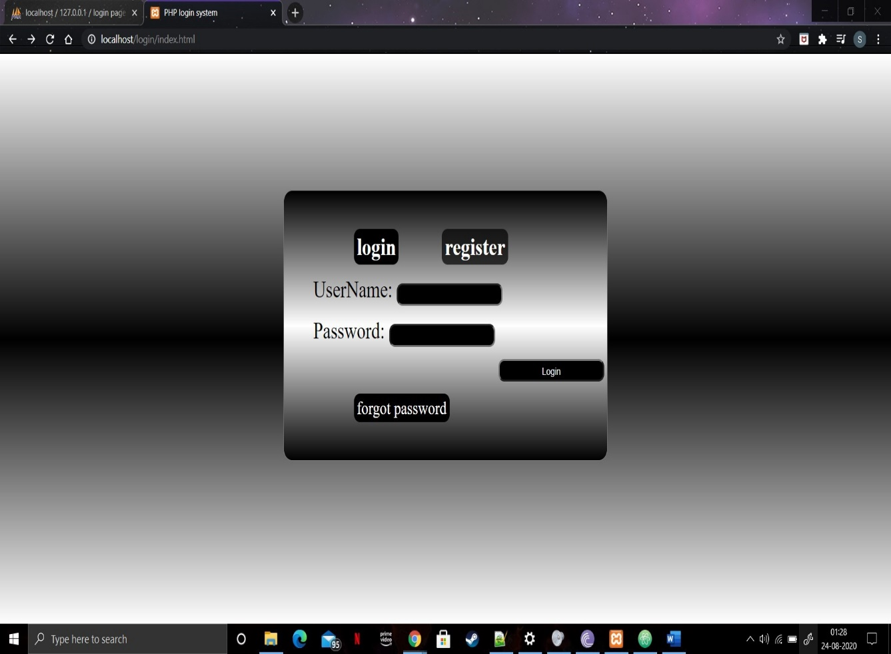

The registration page:

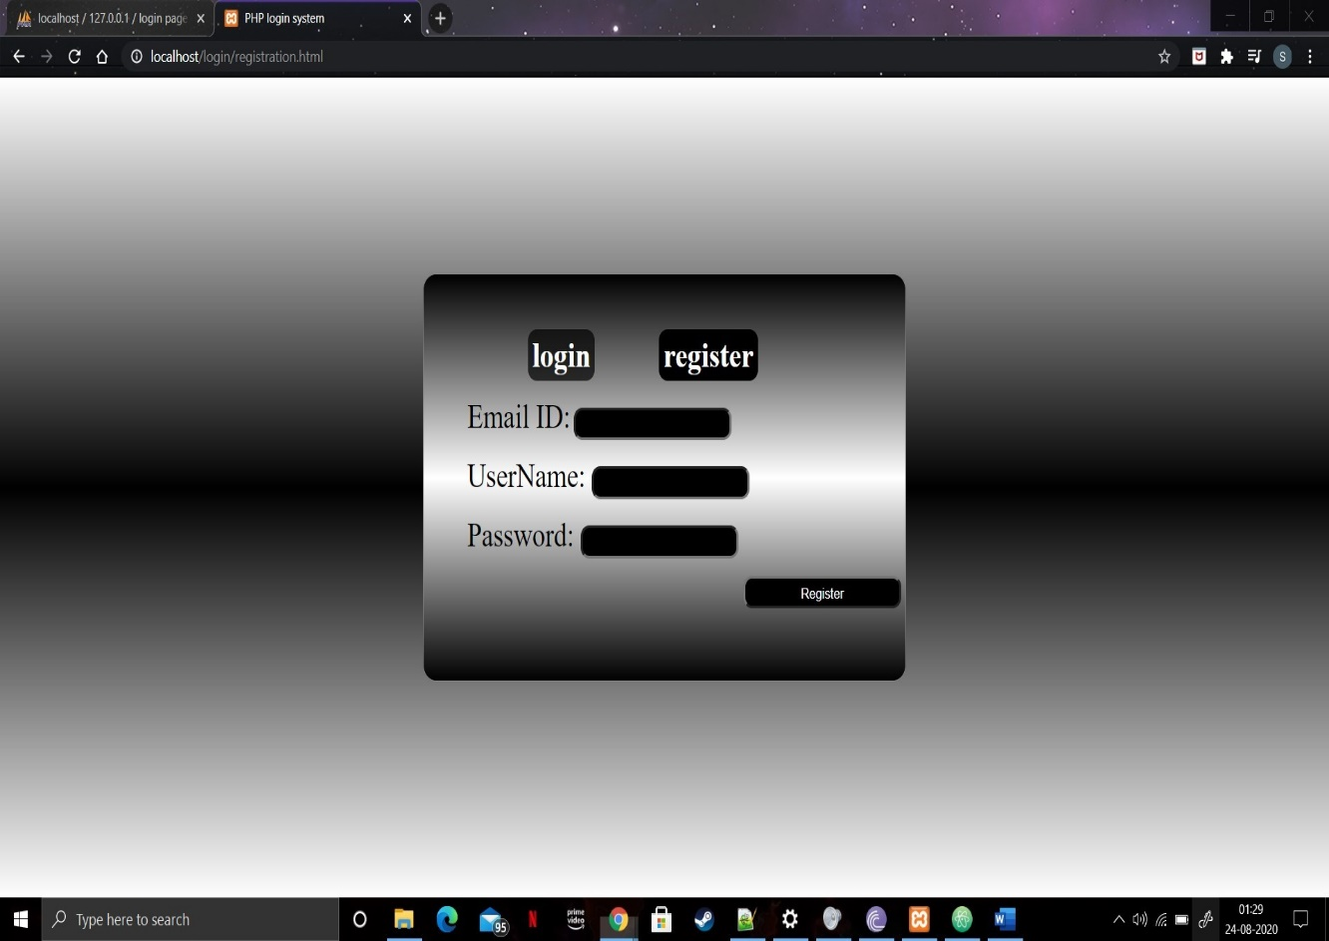

Registration page with details:

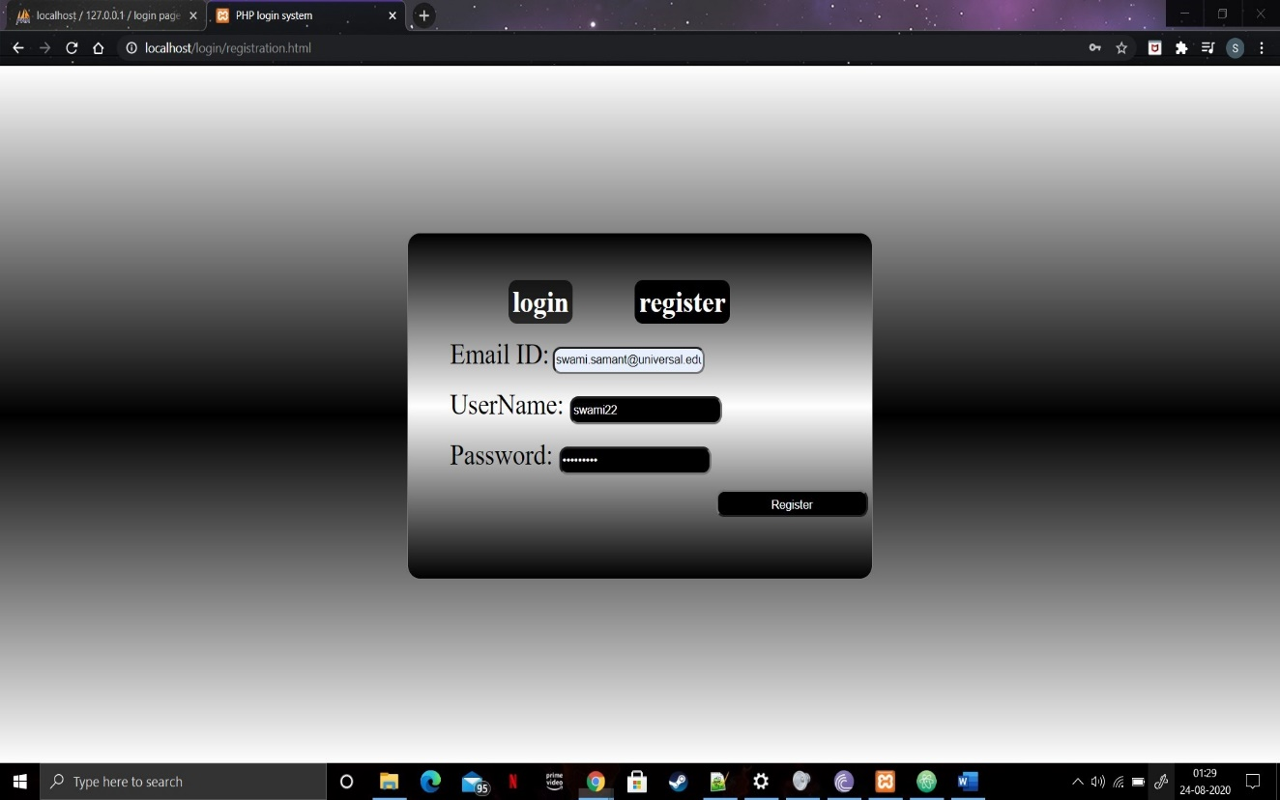

Picture of database after successful registration:

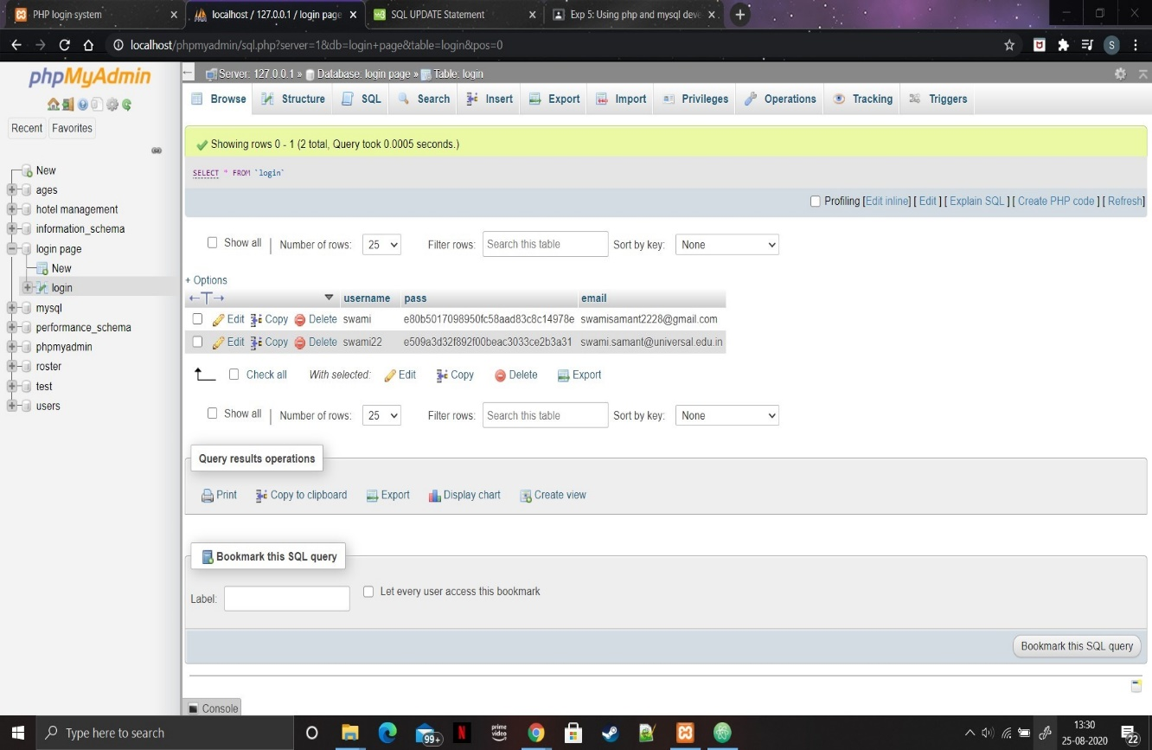

Login with right password:

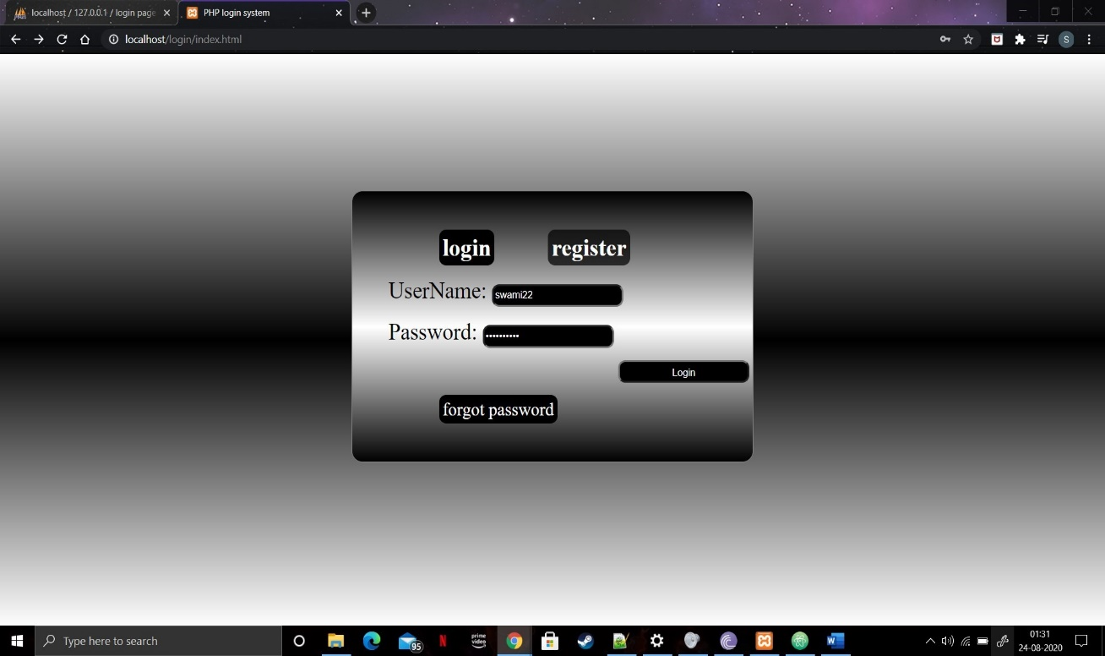

Login successful:



If wrong password is entered:



Incase the user forgot his password:

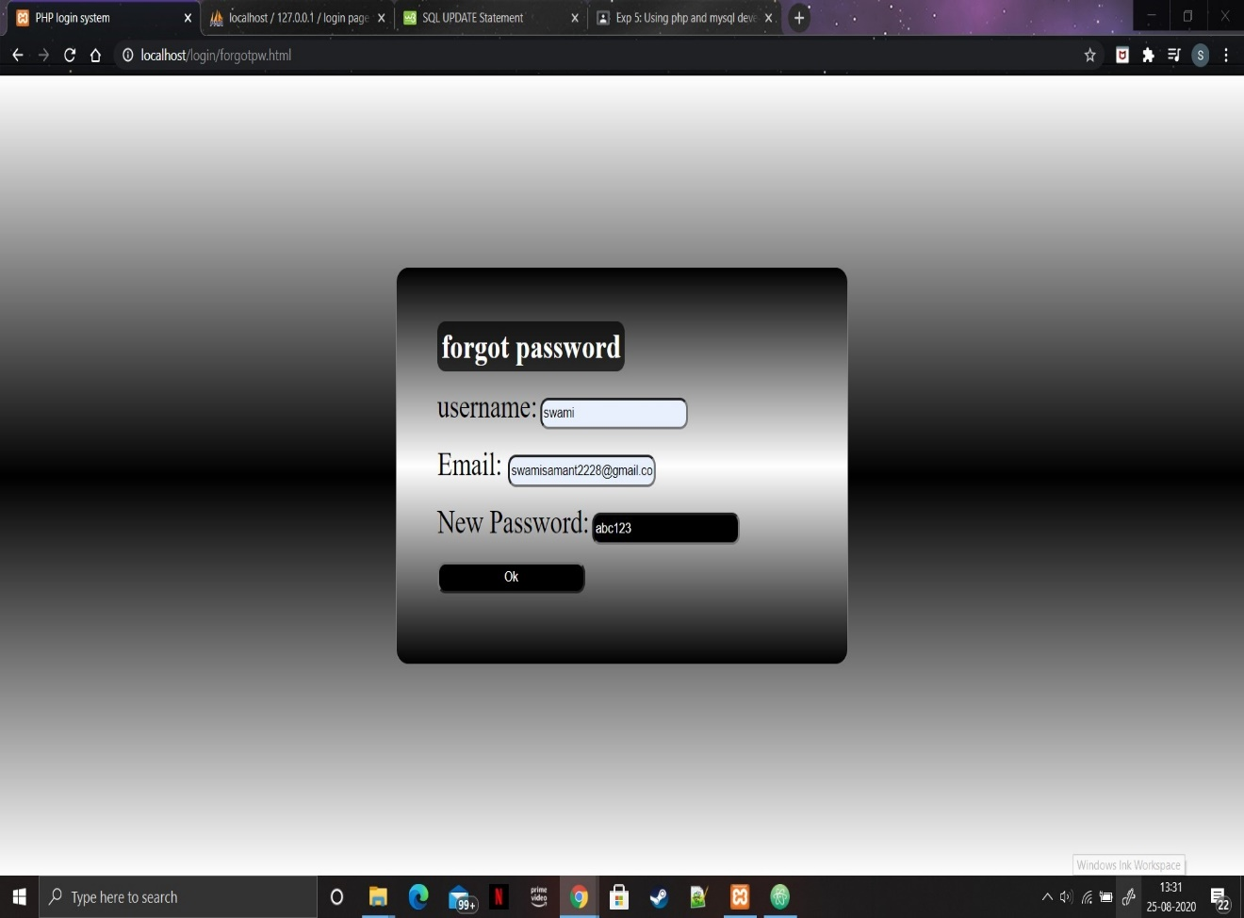

Database after changing password stored in hash:

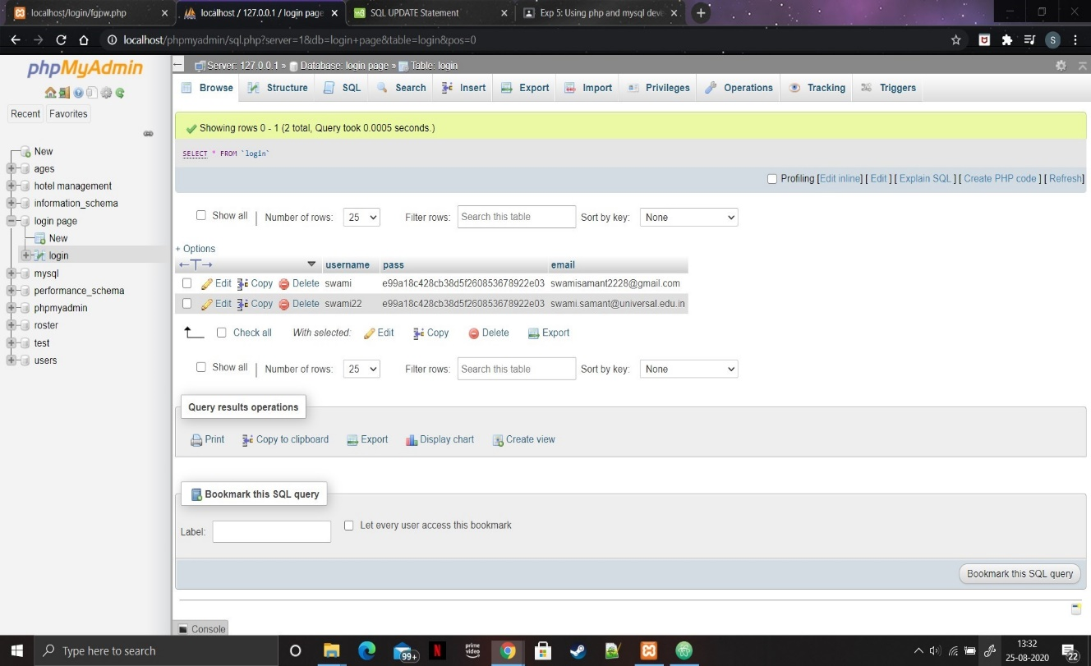

If the right username and email is entered:



If wrong username or password is entered:



**Conclusion:** hence we learned how to access database using php and create a login/registration page.